**INSTITUTE OF ENGINEERING**

ADVANCED COLLEGE OF ENGINEERING AND MANAGEMENT

Kupondole, Lalitpur

**(AFFILIATED TO TRIBHUVAN UNIVERSITY)**



Lab no:6

Subject: Computer Network

**Submitted By: Submitted To:**

Department of Computer

and

Electronics Engineering

Name: Sameep Dhakal

Roll no: ACE074BCT063

Date: 09/07/2021

# Lab 6

# Title: Dynamic Host Configuration Protocol (DHCP)

# Objective:

* To Learn about automatically providing the Ip address to devices on same network

# Introduction:

The Dynamic Host Configuration Protocol (DHCP) is a [network management protocol](https://en.wikipedia.org/wiki/Network_protocol) used on [Internet Protocol](https://en.wikipedia.org/wiki/Internet_Protocol) (IP) networks for automatically assigning IP addresses and other communication parameters to devices connected to the network using a client-server architecture.

The technology eliminates the need for individually configuring network devices manually, and consists of two network components, a centrally installed network DHCP [server](https://en.wikipedia.org/wiki/Server_(computing)) and client instances of the protocol stack on each computer or device. When connected to the network, and periodically thereafter, a client [requests](https://en.wikipedia.org/wiki/Request%E2%80%93response) a set of parameters from the DHCP server using the DHCP protocol.

# Design:

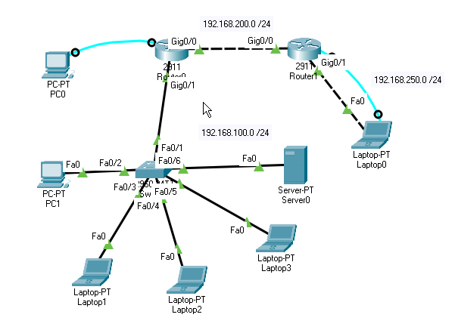

# Procedure:

1. First the required tools are selected.
2. The required ports of the routers were turned on.
3. Then Ip and subnet mask of the routers and server were set
   1. For each laptop and pc this was done by going to the desktop and Ip configurations and enabling the DHCP, which will provide the Ip addresses to devices
   2. For routers this was done by going to the configuration and selecting the required port
4. Required connections were made between the routers and laptops.
5. Then Static routing is done for the connection of the devices in different network.

# Code:

Router0> en

Router0# conf t

Router0(config)#host R1

R1(config)#int g0/1

R1(config-if)#ip add 192.168.100.1 255.255.255.0

R1(config-if)#no shut

R1(config-if)#int g0/0

R1(config-if)#ip add 192.168.200.1 255.255.255.0

R1(config-if)#no shut

R1(config-if)#exit

R1(config)#ip route 192.168.250.0 255.255.255.0 192.168.200.2

R1(config)#end

R1#wr

Router1>enable

Router1#configure terminal

Router1(config)#host R2

R2(config)#interface GigabitEthernet0/0

Router(config-if)#ip address 192.168.200.2 255.255.255.0

R2(config-if)#no shutdown

R2(config-if)#exit

R2(config)#interface GigabitEthernet0/1

R2(config-if)#ip address 192.168.250.1 255.255.255.0

R2(config-if)#no shutdown

R2(config-if)#exit

R2(config)#ip route 192.168.100.0 255.255.255.0 192.168.200.1

R2#wr

# Output:

Server 0

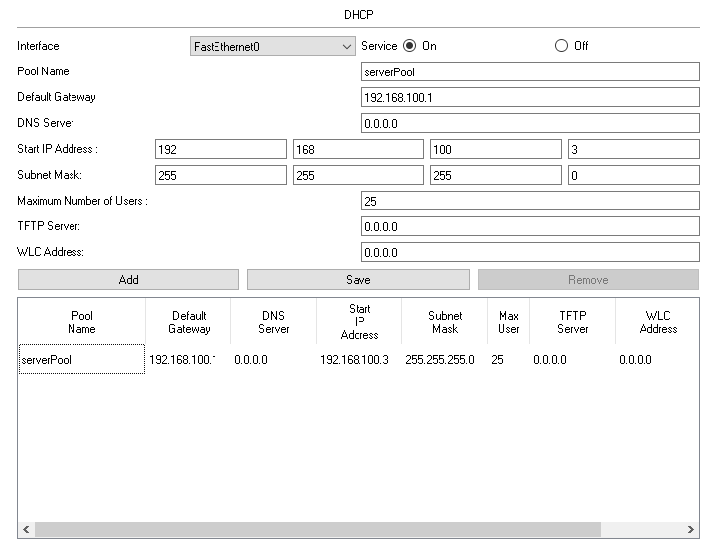

1.PC1

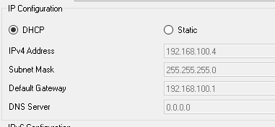

Ping Pc1 to Laptop 0

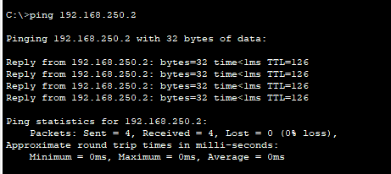

2. Laptop1

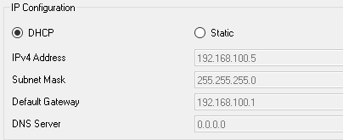

Ping Laptop1 to Laptop0

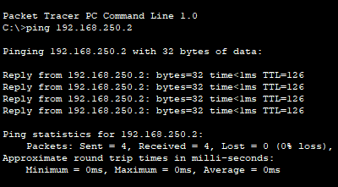

3. Laptop 2

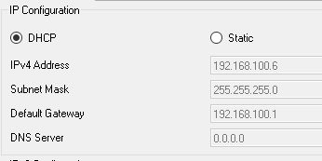

Ping Laptop2 to Laptop0

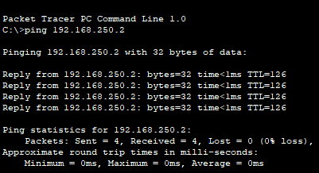

4. Laptop 3

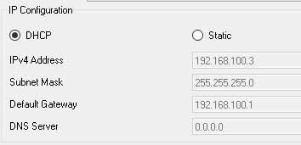

Ping Laptop3 to Laptop0

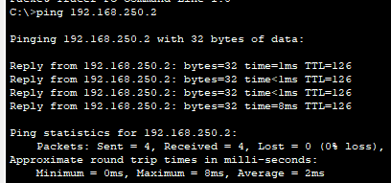

# Result and Conclusion

In this Lab we were able to automatically provide Ip addresses to the devise on same network by enabling DHCP server and able to ping with devices on different network using static routing.